Task 8: Power BI Dashboard
Page:1 -KPI
This page shows the main KPIs of the CoreTech business data. It includes Total Clients, Total Revenue, Completed Projects, Pending Projects, Average Rating, and Top Service. These KPIs help us understand the overall business performance in a simple way.
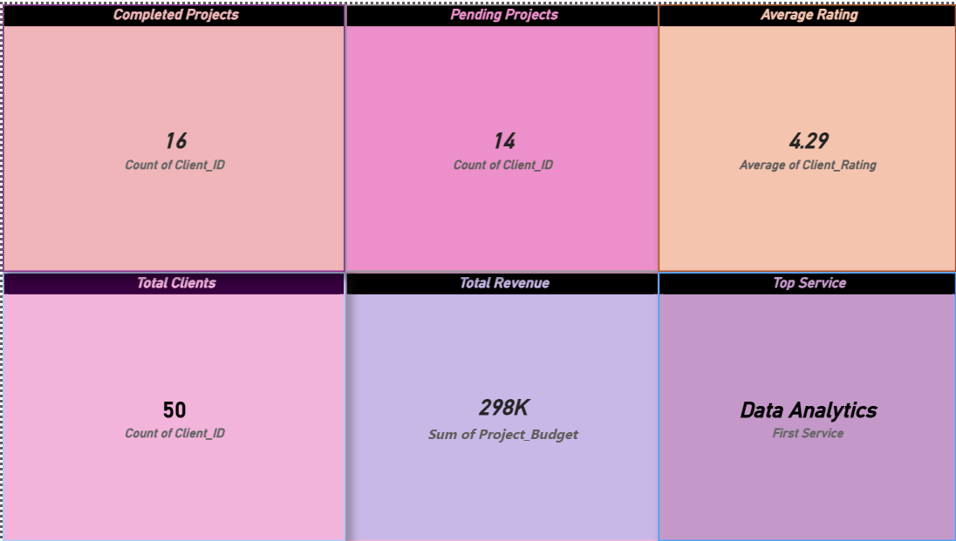

Page:2 -Charts and Analysis
This page shows the business data using different charts and a table. It includes Revenue by Service, Project Status, Clients by City, and Payment Status. The slicers help us filter the data by city, service, and project status to make the analysis easier.

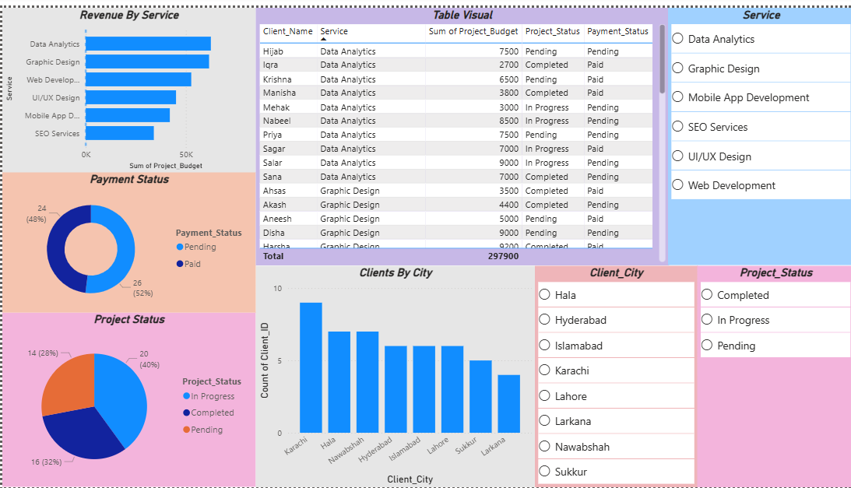

5 Key Insights
- Data Analytics is the top service with the highest revenue.
- Most projects are in progress.
- Karachi has the highest number of clients.
- Most payments are completed, while some are still pending.
- The dashboard makes it easy to understand and analyze the business data.

